ENVIRONMENTAL MONITORING IN PARK SYSTEM

* Environmental monitoring gives information to data center personal regarding the condition of the whole facility it does not matter how small a data center is the facility has to remain online
* Environmental monitoring provides real time access to the temperature ,humidity, and other environmental states of the data centers. the data logged on the system can be accessed at all times. In addition to real time historical data allow analysis of trends

And diagnosis of problem



* Wireless technologies other than WIFI are available which provides enhance security . wireless radio such as LoRa does not even touch the man IP address
* It sense real time alerts to the operator if sensor parameter are outside of defined thresholds

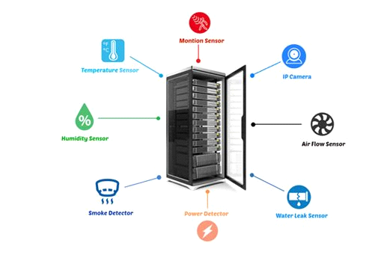

REAL TIME ENVIRONMENTAL MONITORING SYSTEM

* Environmental monitoring is the process of measuring and analysis the quality and condition
* parameter temperature , optics, velocity ,passive, infrared(PIR), level and flow

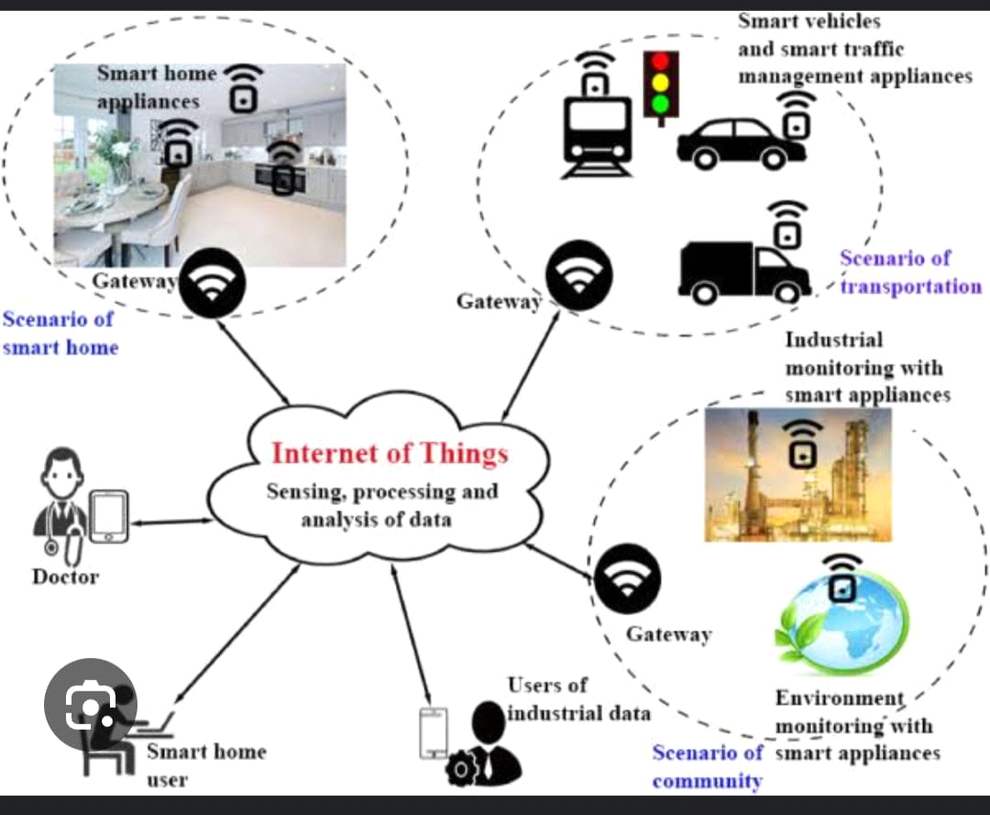

IOT DEVICE DEVELOPMENT, AND CODE IMPLEMENTATION

* SCALABILITY

Create a platform that can scale with the increasing the number of IOT devices , ensuring it can handle large volumes of data and devices efficiently

* SECURITY:

Implement robust security measure to protect the data , devices and the platform itself from cyber threats and unauthorized access

* REAL-TIME MONITORING:

Enable real time monitoring of IOT devices and the data they generate , allowing for immediate response to events and issue

***PYTHON SCRIPT***

***#*!/usr/bin/python**

***import struct, array, time, io, fcntl***

***I2C_SLAVE=0x0703bus=1***

***fr = io.open("/dev/i2c-"+str(bus), "rb", buffering=0) fw = io.open("/dev/i2c-"+str(bus), "wb", buffering=0)***

***# set device address***

***fcntl.ioctl(fr, I2C_SLAVE, HDC1008_ADDR)***

***fcntl.ioctl(fw, I2C_SLAVE, HDC1008_ADDR)***

***time.sleep(0.015) #15ms startup time***

***s=[0x02,0x02,0x00]***

***s2=bytearray(s)***

|  |  |
| --- | --- |
| ***#sending config register bytes*** |  |

***fw.write( s2 )***

***time.sleep(0.0625) # From the data sheet***

***data = fr.read(2) #read 2byte temperature databuf=array.array('B',data)print ( "Temp: %f" % ( ((((buf[0]<<8) + (buf[1]))/65536.0)*165.0 ) - 40.0 ) )***

***time.sleep(0.015) # From the data sheet***

***s=[0x01]***

***fw.write(s2) #Fromthedatasheet***

***time.sleep(0.0625)***

***data=fr.read(2)***

***#read 2 byte temperature data***

***buf = array.array('B', data)  
print ( "Humidity: %f" % ( ((((buf[0]<<8) + (buf[1]))/65536.0)*100.0 ) ) )***

BENEFITS OF PARK VISITORS

* Weather updates :

Park visitors can check real time weather information, which aids in planning activities , ensuring they are well prepared for rain ,snow, extreme heat

* Natural events :

Visitors can be alerted to natural events like blooming wildflowers, fall foliage, or specific animal migrations, encouraging them to visit the park during these special times

***Index.html***

<html>

    <head>

        <title>website design using html css</title>

        <link rel="stylesheet" href="style.css">

    </head>

    <body>

        <div class="main">

            <nav>

                <div class="nav-links">

                    <ul>

                        <li><a href="#">sensor</a></li>

                        <li><a href="#">camera</a></li>

                        <li><a href="#"></a>park monitoring</li>

                        <li><a href="#">humidity temperature</a></li>

                    </ul>

                </div>

            </nav>

            <div class="information">

                <img src="C:\Users\JSECPC06\Downloads\InShot_20231030_223432661.jpg" class="IOT">

                <div id="circle">

                    <div class="feature one">

                        <div>

                            <img src="C:\Users\JSECPC06\Downloads\Screenshot (6)-1.png">

                            <h1>sensor</h1>

                            <p>raspberry</p>

                        </div>

                    </div>

                    <div class="feature two">

                        <img src="C:\Users\JSECPC06\Downloads\Screenshot (8).png">

                        <div>

                            <h1>camera</h1>

                            <p>checking monitoring the visitor</p>

                        </div>

                    </div>

                    <div class="feature three">

                        <img src="C:\Users\JSECPC06\Downloads\Screenshot (4).png">

                        <div>

                            <h1>park monitoring</h1>

                            <p> environmental park also monitore</p>

                        </div>

                    </div>

                    <div class="feature four">

                        <img src="C:\Users\JSECPC06\Downloads\Screenshot (11).png">

                        <div>

                            <h1>humidity temperature</h1>

                            <p>calculate the surrounding temperature</p>

                        </div>

                    </div>

                </div>

            </div>

            <div class="controls">

                <img src="C:\Users\JSECPC06\Downloads\Screenshot (14).png" id="upBtn">

                <h3>features</h3>

                <img src="C:\Users\JSECPC06\Downloads\uparrow.png" id="downBtn">

            </div>

        </div>

        <script>

**var** cir = document.getElementById("circle");

**var** up = document.getElementById("upBtn");

**var** down = document.getElementById("downBtn");

**var** rotatevalue = circle.style.transform;

**var** rotatesum;

             upBtn.onclick = **function** rotateElem()

             {

                rotatesum = rotatevalue +"rotate(-90deg)";

                circle.style.transform = rotatesum;

                rotatevalue = rotatesum;

             }

             downBtn.onclick = **function**()

             {

                rotatesum = rotatevalue +"rotate(90deg)";

                circle.style.transform = rotatesum;

                rotatevalue = rotatesum;

             }

        </script>

    </body>

</html>

***Style.css***

*{

    margin: 0;

    padding: 0;

    front-family: sans-serif;

}

.main{

    width: 100%;

    height: 100vh;

    position: relative;

    overflow: hidden;

    background: linear-gradient(to right, #7115a2, #348ed3 );

}

 nav{

     width: 80%;

     position: sticky;

     margin: 20px auto;

     z-index: 1;

     display: flex;

     align-items: center;

}

.nav-links{

    flex: 1;

    text-align: right;

}

.nav-links ul li{

    list-style: none;

    display: inline-block;

    margin: 0 20px;

}

.nav-links ul li a{

    color: #7e2162;

    text-decoration: none;

}

.information{

    width: 1000px;

    height: 1000px;

    position: absolute;

    top:50%;

    left: -20%;

    transform: translateY(-40%);

}

#circle{

    width: 1000px;

    height: 1000px;

    position: absolute;

    top:0;

    left: 0;

    border-radius: 50%;

    transform: rotate(0deg);

    transition:1s;

}

.feature img{

    width: 70px;

}

.feature{

    position:absolute;

    display: flex;

    color: #fff;

}

.feature div{

    margin-left: 30px;

}

.feature div p{

    margin-top: 20px;

}

.one{

    top: 450px;

    right: 50px;

}

.two{

    top: 50px;

    left: 350px;

    transform: rotate(-90deg);

}

.three{

    bottom: 450px;

    left: -100px;

    transform: rotate(-180deg);

}

.four{

    bottom: -10px;

    right: 350px;

    transform: rotate(-270deg);

}

.IOT{

    width: 200px;

    position: absolute;

    top: 50%;

    right: 25%;

    transform: translatey(-50%);

    z-index: 1;

}

.controls{

    position: absolute;

    right: 10%;

    top: 50%;

    transform: translateY(-50%);

}

.control h3{

    margin: 15px 0;

    color: #fff;

}

#upBtn{

    width: 15px;

    cursor:pointer;

    transform:rotate(180deg);

}

#downBtn{

    width: 15px;

    cursor: pointer;

    transform: rotate(180deg);

}

***Script.json***

var temp = 85;

var hum = 10;

var HIADJ;

var HI = -42.379 + 2.04901523*temp + 10.14333127*hum - .22475541*temp*hum - .00683783*temp*temp - .05481717*hum*hum + .00122874*temp*temp*hum + .00085282*temp*hum*hum - .00000199*temp*temp*hum*hum;

console.log("Prelimenary Heat Index is " + HI);

if (hum < 13 && temp > 80 && temp < 112) {

  var x = ((13 - hum)/4) * (Math.sqrt(17-Math.abs(temp-95)/17));

  HIADJ = HI - x;

  console.log("Subtracted x=" + x + ". Newl heat index after adjustment is HIADJ= " + HIADJ);

} else if (hum > 85 && temp > 80 && temp < 87) {

  var y = ((hum - 85)/10)*((87-temp)/5);

  HIADJ = HI + y;

  console.log("Added y=" + y + ". Newl heat index after adjustment is HIADJ=" + HIADJ);

} else {

HIADJ = HI;

console.log("Heat index with no adjustment is " + HIADJ);

    }

output:



    
    
    

